REGISTRATION NUMBER – 16BIT0453
KRISHNA KUMAR MAHTO

EXPERIMENT-7

CODE:

#include<stdio.h>
#include<stdlib.h>

#define MAX 5
#define false 0
#define true 1

//n = number of processes
//m = number of resource types
//compare = matrix comparator

int available[MAX]; //holds available number of instances for each resource i
int max[MAX][MAX]; //n*m matrix holds max demand for each process
int allocation[MAX][MAX]; //n*m matrix holds number of resources of each type allocated to each process
int need[MAX][MAX]; //n*m matrix remaining resource need for each process
int n=0,m=0;
int request[MAX];
int safe_sequence[MAX];

void present_snapshot()
{
int i,j;
char ch;

puts("\tAllocation Matrix\n");
for(ch='A',i=0;i<m;i++,ch++)
printf("\t%c",ch);
puts("\n");

for(i=0;i<n;i++)
{
printf("P%d",i);
for(j=0;j<m;j++)
printf("\t%d",allocation[i][j]);
puts("");
}
puts("");

puts("\tMax Matrix\n");
for(ch='A',i=0;i<m;i++,ch++)
printf("\t%c",ch);
puts("");

for(i=0;i<n;i++)
{
printf("P%d",i);
for(j=0;j<m;j++)
printf("\t%d",max[i][j]);
puts("");
}
puts("");

puts("\tAvailable Matrix\n");
for(ch='A',i=0;i<m;i++,ch++)
printf("\t%c",ch);
puts("");

for(j=0;j<m;j++)
printf("\t%d",available[j]);
puts("");

}

int compare(int need[],int work[])
{
int j;
for(j=0;j<m;j++)
{
if(need[j]<=work[j])
continue;
else
return 0;
}
if(j==m-1)
return 1;
}

int safety_algorithm()
{
int finish[n],ss=0, *work, i, j, flag = false, safe = true, count,cycle;

work = (int*)malloc(sizeof(int)*MAX);

work = available;
for(i=0;i<n;i++)
finish[i]=false;
for(count=0,cycle = 0;count<n && cycle < 2*n;cycle++) //if the loop runs twice through the processes and still finish[i] = false for some process(es), then no safe sequeunce found
{
for(i=0;i<n;i++)
{
if((finish[i]==false) && compare(need[i],work))
{
count++;
flag = true;
for(j=0;j<m;j++)
work[j] += allocation[i][j];
finish[i] = true;
safe_sequence[ss++] = i;
continue;
}

else if(i<n-1)
continue;
}
}

for(i=0;i<n;i++)
if(finish[i] == false)
{
safe = false;
break;
}

if(ss == n-1)
{
puts("Safe sequence: ");
printf("< ");
for(i=0;i<n;i++)
{
printf("%d, ",safe_sequence[i]);
}
printf(">");
puts("");
}

return safe;

}

int main(int argc,char *argv[])
{

int i,j,requesting_process,safe; //i for iterating through n processes and j for iterating through m processes
char ch;

puts("Enter the number of processes: ");
scanf("%d",&n);
puts("");

puts("Enter the number of resource types: ");
scanf("%d",&m);
puts("");

puts("Enter the Available matrix");
for(j=0;j<m;j++)
{
printf("Resource %d: ",j);
scanf("%d",&available[j]);
}
puts("");

puts("Enter the Max matrix: ");
for(i=0;i<n;i++)
{
printf("Process %d\n",i);
for(j=0;j<m;j++)
scanf("%d",&max[i][j]);
puts("");
}
puts("");

puts("Enter the Allocation matrix:");
for(i=0;i<n;i++)
{
printf("Process %d\n",i);
for(j=0;j<m;j++)
scanf("%d",&allocation[i][j]);
puts("");
}
puts("");

for(i=0;i<n;i++)
for(j=0;j<m;j++)
need[i][j]=max[i][j]-allocation[i][j];
puts("");

/* NEED MATRIX PRINT*/
puts("\tNeed Matrix");
for(ch='A',i=0;i<m;i++,ch++)
printf("\t%c",ch);

puts("");
for(i=0;i<n;i++)
{
printf("P%d",i);
for(j=0;j<m;j++)
printf("\t%d",need[i][j]);
puts("");
}
puts("");

present_snapshot();

safe = safety_algorithm();

if(safe == false)
{
puts("System is in unsafe state!");
puts("Exiting...");
exit(1);
}

else
{
puts("Enter the process requesting: ");
scanf("%d",&requesting_process);

puts("Enter the Request matrix: ");
for(j=0;j<m;j++)
scanf("%d",&request[j]);

if(compare(request,need[requesting_process]))
{
if(compare(request,available))
{
for(j=0;j<m;j++)
{
available[j] = available[j]-request[j];
allocation[requesting_process][j] = allocation[requesting_process][j] + request[j];
need[requesting_process][j] = need[requesting_process][j] - request[j];
}
safe = safety_algorithm();

if(safe)
{
puts("Resources allocated successfully.");
exit(0);
}
else
{
//restore to previous allocation state
available[j] = available[j] + request[j];
allocation[requesting_process][j] = allocation[requesting_process][j] - request[j];
need[requesting_process][j] = need[requesting_process][j] + request[j];
}

}
else
{
printf("Process_%d must wait\n",requesting_process);
exit(1);
}
}
else
{
puts("Maximum request limit exceeded");
exit(1);
}
}
return 0;
}

OUTPUT:
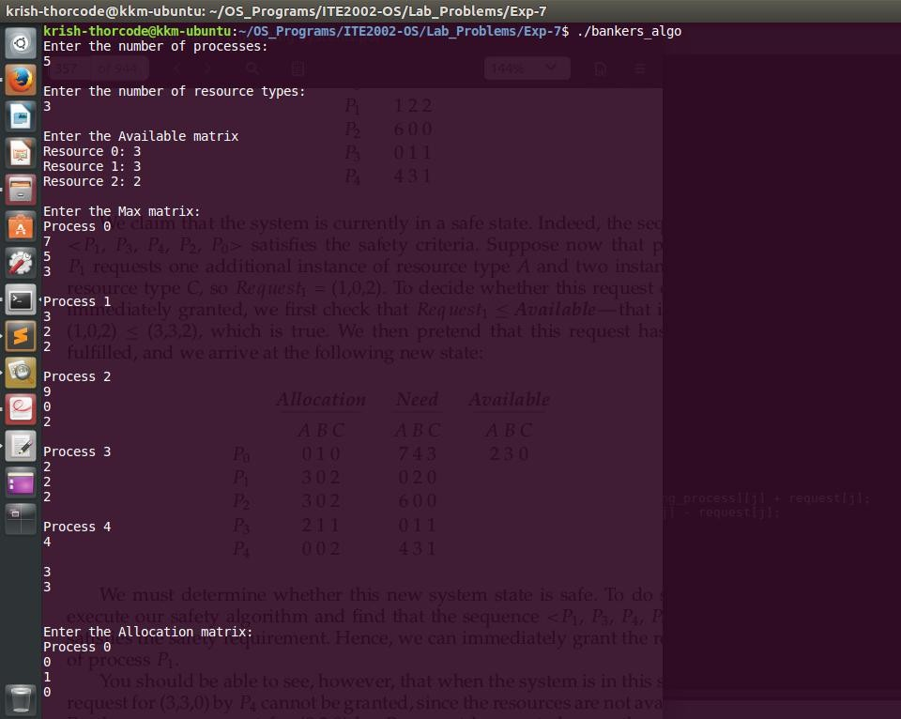

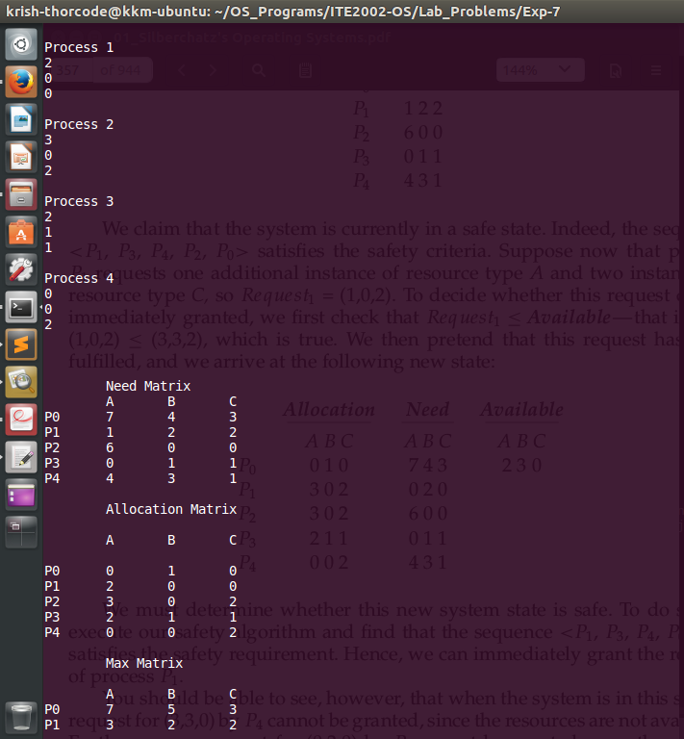

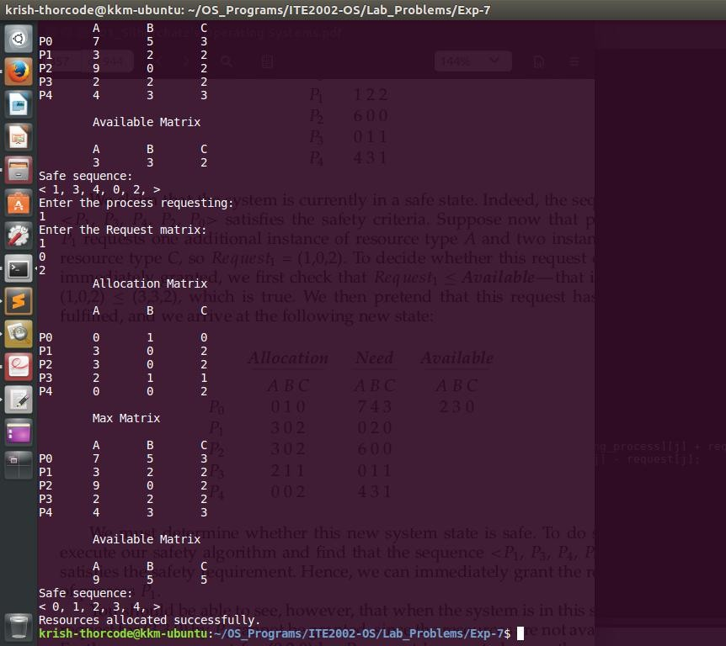

b.) For the given snapshot:

i)
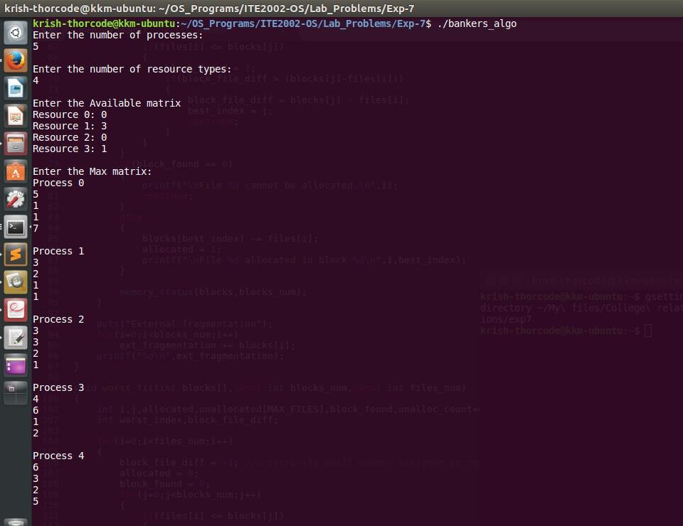
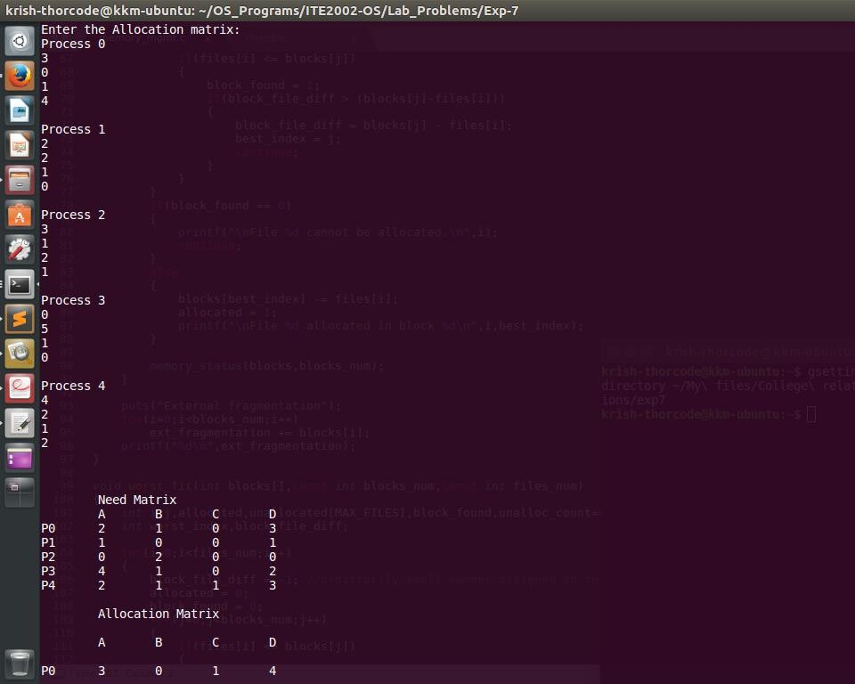
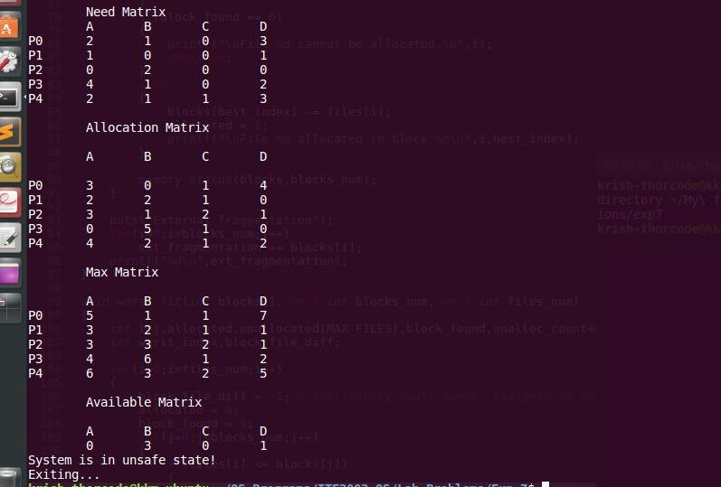

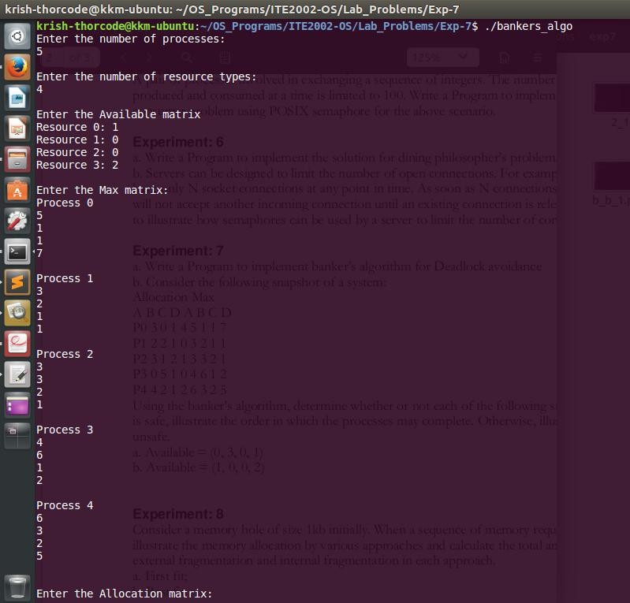
ii.)
